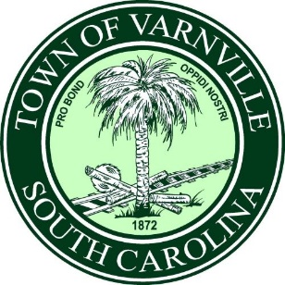

Invitation for Demolition Bid

Project Name: Nuisance abatement;
Project Location: 964 Carolina Ave. Varnville, SC 29944/ TM # 119-12-05-003 /Owner of Record; Nakita Orr
Bid Submission Deadline: March 31st, 2025

Contact Information:
Submit bids to ;
Mayor Nat Shaffer,
95 E. Palmetto Ave. Po Box 308, Varnville, SC, 29944
admin@varnville.sc.gov; 803-943-2979

Project Description:
The Town of Varnville is seeking bids from qualified demolition contractors for the demolition and site clearance of 964 Carolina Avenue Varnville, SC 29944. The project includes the demolition AND removal of dwelling / structure including the foundation, and any debris and vehicles on the lot.

Disclosure:
- The successful bidder will be required to obtain a Town of Varnville business license and applicable building / demo permit.
- This solicitation does not commit the Town of Varnville to award contract, pay any cost incurred in the preparation of a bid, or to procure contract for the services. The Town of Varnville reserves the right to reject any responses and make an award deemed in the public’s best interest.

